**AccessHUB NextGen Add/Remove Teams**

*AccessHUB NextGen works with your W3id. This means There is no need to request access to AH NG.*

* **Steps to Add/Remove Teams.**

Open browser to [AccessHUB NextGen](https://ibm-support.saviyntcloud.com/ECMv6/request/requestHome) home page, and click **"Manage My Access".**

* Click “Modify” on “SOS GH” App.

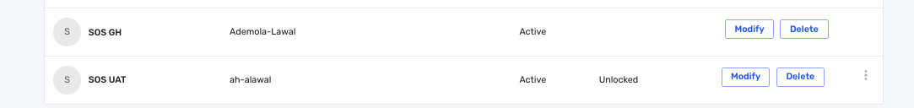

* On the “Modify Access” page, you can Add or Remove groups.

ADDING TEAMS.

* To Add Teams, click on "Add", and on the pop out page,

Select the team you want added.

* To add privilege (maintainer/member) to your team. Toggle the “Do you want to add privilege button” on the top right of the page, then click "Done".

* Click the “Review & Submit” button.

* Provide Business Justification:

This is needed for audit purposes. Try providing as much information as possible, such as your team and reason why you need access, otherwise the approver may not approve the request due to insufficient information.

* Checkbox and click-on "Submit."

REMOVING TEAMS

* To Remove Team, click on the delete icon next to the team’s name. Provide Business Justification, (this is required for audit purposes so provide a detailed reason for removal).

* Click-on "Review & Submit".

